Sermon Notes
“Giving Thanks”
Matthew 17:1-2
After six days Jesus took with him Peter, James and John the brother of James, and led them up a high mountain by themselves. ² There he was transfigured before them. His face shone like the sun, and his clothes became as white as the light.

I’m thankful for ____________________

I’m thankful for ____________________

I’m thankful for ____________________

I’m thankful for ____________________

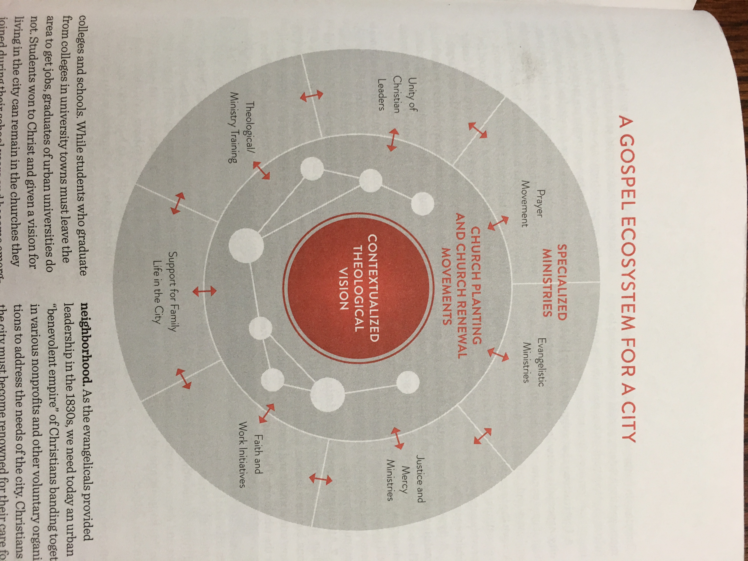

Notes

Questions for Discussion:

1. What was the most helpful, challenging, or inspiring part of Sunday’s testimony for
you? Why?
2. Share a time in your life where God moved in your life in an especially powerful and tangible way.
3. What do you find yourself giving thanks for in this current season?
4. Why do you think the Scripture calls us to give thanks so often? (e.g. Psalm 100:4, 1 Thessalonians 5:18, Colossians 3:17, Psalm 106:1, Psalm 7:17) How does the habit of gratitude and thankfulness shape us? How does the ingratitude and a lack of thankfulness shape us?
5. “Giving thanks is a spiritual discipline.” Do you agree with that statement? Why or why not?
6. Jeff shared his vision to help create a “gospel eco-system” for the city of Nelson. What aspect of that eco-system could you see yourself serving in/through?

