Sermon Notes
“The Spiritual Journey of the 40’s”

The Spirituality of the Two Halves of Life

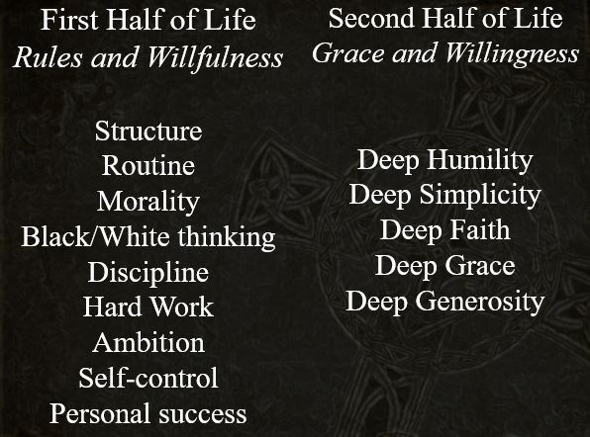

1 Kings 19:1–21
¹ Now Ahab told Jezebel everything Elijah had done and how he had killed all the prophets with the sword. ² So Jezebel sent a messenger to Elijah to say, “May the gods deal with me, be it ever so severely, if by this time tomorrow I do not make your life like that of one of them.” ³ Elijah was afraid and ran for his life.

- Temptation #1: ___________________________________

When he came to Beersheba in Judah, he left his servant there, ⁴ while he himself went a day’s journey into the wilderness.

- Temptation #2: ___________________________________

He came to a broom bush, sat down under it and prayed that he might die. “I have had enough, Lord,” he said. “Take my life; I am no better than my ancestors.”

- Temptation #3: _______________________________

⁵ Then he lay down under the bush and fell asleep. All at once an angel touched him and said, “Get up and eat.”

- Truth #1: God meets us where ________________, not where __________________________________________-.

⁶ He looked around, and there by his head was some bread baked over hot coals, and a jar of water. He ate and drank and then lay down again. ⁷ The angel of the Lord came back a second time and touched him and said, “Get up and eat, for the journey is too much for you.”

- Truth #2: The journey ________________________________ for you.

⁸ So he got up and ate and drank. Strengthened by that food, he traveled forty days and forty nights until he reached Horeb, the mountain of God.

- Truth #3: God _________________ us in order that we may _________________________________ Him.

⁹ There he went into a cave and spent the night. And the word of the Lord came to him: “What are you doing here, Elijah?” ¹⁰ He replied, “I have been very zealous for the Lord God Almighty. The Israelites have rejected your covenant, torn down your altars, and put your prophets to death with the sword. I am the only one left, and now they are trying to kill me too.” ¹¹ The Lord said, “Go out and stand on the mountain in the presence of the Lord, for the Lord is about to pass by.” Then a great and powerful wind tore the mountains apart and shattered the rocks before the Lord, but the Lord was not in the wind. After the wind there was an earthquake, but the Lord was not in the earthquake. ¹² After the earthquake came a fire, but the Lord was not in the fire. And after the fire came a gentle whisper.

- Truth #4: Sometimes God communicates most clearly in _____________________________.

¹³ When Elijah heard it, he pulled his cloak over his face and went out and stood at the mouth of the cave. Then a voice said to him, “What are you doing here, Elijah?” ¹⁴ He replied, “I have been very zealous for the Lord God Almighty. The Israelites have rejected your covenant, torn down your altars, and put your prophets to death with the sword. I am the only one left, and now they are trying to kill me too.” ¹⁵ The Lord said to him, “Go back the way you came, and go to the Desert of Damascus. When you get there, anoint Hazael king over Aram. ¹⁶ Also, anoint Jehu son of Nimshi king over Israel, and anoint Elisha son of Shaphat from Abel Meholah to succeed you as prophet. ¹⁷ Jehu will put to death any who escape the sword of Hazael, and Elisha will put to death any who escape the sword of Jehu. ¹⁸ Yet I reserve seven thousand in Israel—all whose knees have not bowed down to Baal and whose mouths have not kissed him.” ¹⁹ So Elijah went from there and found Elisha son of Shaphat. He was plowing with twelve yoke of oxen, and he himself was driving the twelfth pair. Elijah went up to him and threw his cloak around him. ²⁰ Elisha then left his oxen and ran after Elijah. “Let me kiss my father and mother goodbye,” he said, “and then I will come with you.” “Go back,” Elijah replied. “What have I done to you?” ²¹ So Elisha left him and went back. He took his yoke of oxen and slaughtered them. He burned the plowing equipment to cook the meat and gave it to the people, and they ate. Then he set out to follow Elijah and became his servant.

- Truth #5: ______________________________ is critical to a thriving second-half of life.

Questions for Discussion
1. What was the most personally impactful aspect of Sunday’s message for you?
2. Which of the three temptations Elijah faced do you grapple with the most at your stage of life? How do you combat them?
3. Which truth found in this passage offers you the most comfort at your stage of life?
4. Look up Hebrews 10:24-25. What does this Scripture have to say about the temptation to “go it alone” in the Christian life?
5. How does Romans 12:4-5 challenge us to reject the movement towards self-interest and self-preservation?
6. Read 145:4. How are you involved in commending God’s work to the next generation?
7. Who is an Elisha in your life? What would it look like to spiritually invest in that person more intentionally?

