Sermon Notes
“Suffering Fruitfully”

John 15:1–11
¹ “I am the true vine, and my Father is the gardener. ² He cuts off every branch in me that bears no fruit, while every branch that does bear fruit he prunes so that it will be even more fruitful. ³ You are already clean because of the word I have spoken to you. ⁴ Remain in me, as I also remain in you. No branch can bear fruit by itself; it must remain in the vine. Neither can you bear fruit unless you remain in me. ⁵ “I am the vine; you are the branches. If you remain in me and I in you, you will bear much fruit; apart from me you can do nothing. ⁶ If you do not remain in me, you are like a branch that is thrown away and withers; such branches are picked up, thrown into the fire and burned. ⁷ If you remain in me and my words remain in you, ask whatever you wish, and it will be done for you. ⁸ This is to my Father’s glory, that you bear much fruit, showing yourselves to be my disciples. ⁹ “As the Father has loved me, so have I loved you. Now remain in my love. ¹⁰ If you keep my commands, you will remain in my love, just as I have kept my Father’s commands and remain in his love. ¹¹ I have told you this so that my joy may be in you and that your joy may be complete.

Living in the Overlap of the Ages
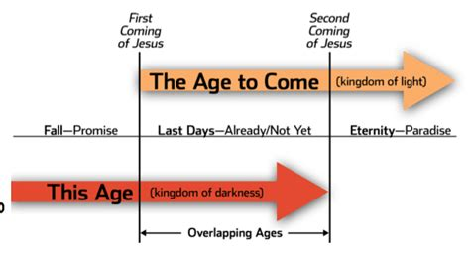
“In this world you will have trouble. But take heart! I have overcome the world.”
John 16:33

1 Peter 5:6–11
6 Humble yourselves, therefore, under God’s mighty hand, that he may lift you up in due time. 7 Cast all your anxiety on him because he cares for you. 8 Be self-controlled and alert. Your enemy the devil prowls around like a roaring lion looking for someone to devour. 9 Resist him, standing firm in the faith, because you know that your brothers throughout the world are undergoing the same kind of sufferings. 10 And the God of all grace, who called you to his eternal glory in Christ, after you have suffered a little while, will himself restore you and make you strong, firm and steadfast. 11 To him be the power for ever and ever. Amen.

How to Suffer Fruitfully

- Get your eyes __________________________ (v. 6)
- Take time to _____________________ (v. 7)

- ________________________! (v. 8)

- ______________ the enemy by __________________________ in the faith (v. 9)

- Live in ________________________ of God's strengthening! (v. 10)

Questions for discussion:
1. What was the most memorable take-away for you from Sunday’s message? How do you plan on applying it to your life this week?
2. How does this sermon challenge the view that Christians should always expect God’s protection from suffering in this life?
3. How does this sermon challenge the view that Christians should never expect God’s protection from suffering in this life?
4. Do you take time to lament loss, suffering, and hardships in your life? Why or why not? What are the practical benefits of casting our cares upon God?
5. What are ways we can stand firm in the faith amidst suffering? What habits of heart, soul, mind, and strength have helped you resist the enemy’s discouragements during times of suffering?
6. Has this sermon better equipped you to love and support those who are suffering and walking through hardships? If so, in what way?

