Sermon Notes
“A Question of Allegiance”

Mark 12:13–17 (NIV)
¹³ Later they sent some of the Pharisees and Herodians to Jesus to catch him in his words. ¹⁴ They came to him and said, “Teacher, we know that you are a man of integrity. You aren’t swayed by others, because you pay no attention to who they are; but you teach the way of God in accordance with the truth. Is it right to pay the imperial tax to Caesar or not? ¹⁵ Should we pay or shouldn’t we?” But Jesus knew their hypocrisy. “Why are you trying to trap me?” he asked. “Bring me a denarius and let me look at it.” ¹⁶ They brought the coin, and he asked them, “Whose image is this? And whose inscription?” “Caesar’s,” they replied. ¹⁷ Then Jesus said to them, “Give back to Caesar what is Caesar’s and to God what is God’s.” And they were amazed at him.

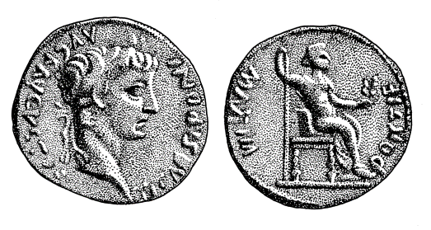
Silver Denarius
“Tiberius Caesar, son of divine Augustus” / “Pontifex Maximus”

17 Then Jesus said to them, “Give back to Caesar what is Caesar’s and to God what is God’s.”
- apodidomi (render/pay back)

Application

1. ______________________________

2. The Kingdom of God is _____________________________ movement. (cf. Romans 13:1-7 and 1 Peter 2:13).

3. Whose ______________ and _____________ are on ___________?

Questions for discussion:
1. What fresh or new-to-you idea stuck out to you in this message?
2. “The kingdom of God is not a political movement (but it has political ramifications).” Do you agree with this statement? Why or why not?
3. Read the following chapters to discover examples of civil disobedience in the Old Testament: Exodus 1, Joshua 2, 1 Kings 18, Daniel 3 and 6.
4. According to 2 Corinthians 3:18, how are we transformed? Is this something that happens automatically? What is our responsibility? How do we participate in this transformation?
5. What “inscriptions” and identity markers have you been living with that you need to confront in light of Jesus’ love for you?

