Sermon Notes
“Renewed Suffering”

2 Corinthians 4:7-18
7 But we have this treasure in jars of clay to show that this all-surpassing power is from God and not from us. 8 We are hard pressed on every side, but not crushed; perplexed, but not in despair; 9 persecuted, but not abandoned; struck down, but not destroyed. 10 We always carry around in our body the death of Jesus, so that the life of Jesus may also be revealed in our body. 11 For we who are alive are always being given over to death for Jesus’ sake, so that his life may also be revealed in our mortal body. 12 So then, death is at work in us, but life is at work in you. 13 It is written: “I believed; therefore I have spoken.” Since we have that same spirit of faith, we also believe and therefore speak, 14 because we know that the one who raised the Lord Jesus from the dead will also raise us with Jesus and present us with you to himself. 15 All this is for your benefit, so that the grace that is reaching more and more people may cause thanksgiving to overflow to the glory of God. 16 Therefore we do not lose heart. Though outwardly we are wasting away, yet inwardly we are being renewed day by day. 17 For our light and momentary troubles are achieving for us an eternal glory that far outweighs them all. 18 So we fix our eyes not on what is seen, but on what is unseen, since what is seen is temporary, but what is unseen is eternal.

Two Ages

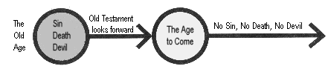
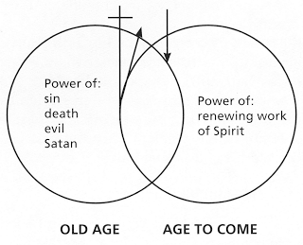

Our Calling in Suffering: Glorify God

- When we suffering, ______________________________

- A___________, S__________, K_____________

Questions for Discussion
- What was the most impactful aspect of this sermon for you?
- Does the fact that we are living in the overlap of the ages help you to understand why we seem to experience great suffering and great redemption in different parts of our lives?
3. Do you tend to veer towards an under-realized eschatology or an over-realized eschatology? Is suffering something you’ve tended to accept or avoid? How has your view shaped the expression of your faith?
4. Have you ever seen someone suffering in such a way that they glorify God and bless others through their suffering? What was distinctive about how they lived out their faith during times of great hardship and suffering?
5. If you are moving through a time of suffering, what might it look like for you to glorify God through your present circumstances?

