Sermon Notes
“Food and Oxygen”

John 15:1–11
¹ “I am the true vine, and my Father is the gardener. ² He cuts off every branch in me that bears no fruit, while every branch that does bear fruit he prunes so that it will be even more fruitful. ³ You are already clean because of the word I have spoken to you. ⁴ Remain in me, and I will remain in you. No branch can bear fruit by itself; it must remain in the vine. Neither can you bear fruit unless you remain in me. ⁵ “I am the vine; you are the branches. If a man remains in me and I in him, he will bear much fruit; apart from me you can do nothing. ⁶ If anyone does not remain in me, he is like a branch that is thrown away and withers; such branches are picked up, thrown into the fire and burned. ⁷ If you remain in me and my words remain in you, ask whatever you wish, and it will be given you. ⁸ This is to my Father’s glory, that you bear much fruit, showing yourselves to be my disciples. ⁹ “As the Father has loved me, so have I loved you. Now remain in my love. ¹⁰ If you obey my commands, you will remain in my love, just as I have obeyed my Father’s commands and remain in his love. ¹¹ I have told you this so that my joy may be in you and that your joy may be complete.

5 characteristics of those who grow in depth and fruitfulness:
- Build rituals
- Maintain accountability
- Grow through hardships
- Practicing spiritual disciplines
- Establish all activity in the gospel of grace

The Importance of applying these to Bible and Prayer.

⁷ If you remain in me and my words remain in you, ask whatever you wish, and it will be given you. ⁸ This is to my Father’s glory, that you bear much fruit, showing yourselves to be my disciples.
Here’s the ritual we want to build: Daily, personal engagement with God through the Bible and Prayer. “Devotional time.”

Why read the Bible?

- Spiritual _________________
- Deuteronomy 8:2–3
- Bible is God’s ______________
- 2 Timothy 3:16–17
- Bible provides ____________ in a world of “fake news.”
- John 17:17
- It provides ______________ and _____________for life.
- Psalm 119:105
- It has a __________________ power. From de-formed image-bearer to re-formed image-bearer.
- Hebrews 4:12
- Bible __________________ Jesus and the gospel of his life, death, and resurrection.
- John 5:39-40
Why pray?

Prayer is ___________________ to life in Christ.

Philippians 4:6–7
⁶ Do not be anxious about anything, but in everything, by prayer and petition, with thanksgiving, present your requests to God. ⁷ And the peace of God, which transcends all understanding, will guard your hearts and your minds in Christ Jesus.

How to Structure a Devotional Time (Food and Oxygen)

1. Devotional book/booklet
- Pray
- Read devotional (scripture and thought)
- Pray and take action
- Devotionals: https://www.crosswalk.com/devotionals

2. Read through a book of the Bible
- Choose a book (Gospels, New Testament, Psalms, Proverbs, Old Testament).
- Bible Project Read Scripture videos (https://www.youtube.com/user/jointhebibleproject).
- Use a Study Bible.
- Pray. Read 2-3x. Notes. Reflect. Pray through passage. Take action.

3. Reading plan (several daily readings).
- Pray
- Read all Scriptures (Use a study Bible).
- Focus on one.
- Read 2-3x. Notes. Reflect. Pray through passage. Take action.
- Reading plans: (https://www.ligonier.org/blog/bible-reading-plans)

Best Study Bibles:
- NIV Cultural Backgrounds Study Bible
- NIV, Faith and Work Bible
- ESV Study Bible
- NIV, Understand the Faith Study Bible
- Zondervan NIV Study Bible
2018: “Clarifying the Bible” Course

Prayer Supports:
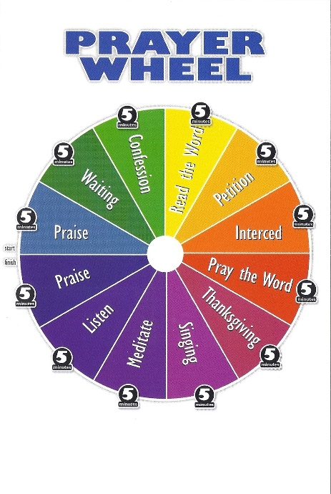

A.C.T.S Prayer Structure

- Adoration: Give God praise and honor for who He is as Lord over all.
- Confession: Honestly deal with the sin in your life.
- Thanksgiving: Verbalize what you’re grateful for in your life and in the world around you.
- Supplication: Pray for the needs of others and yourself.

Do something rather than nothing.
Persistence instead of perfection.

Questions for Discussion
- What insight from the message left the biggest impression on you? Why?
- What personal need in your life did the message expose? How can others pray for and with you in relation to this need?
- Review the Scriptures Jeff cited under “why read the Bible?” Which one most powerfully challenges and/or inspires you?
- What is the single biggest obstacle you face in developing a vibrant devotional life? How could friends or members of your small group help you deal with these obstacles?
- What could be the personal and corporate consequences of not heeding this message?

