Sermon Notes
“Which Spiritual Gifts Are For Today?”
Ephesians 4:7–16
⁷ But to each one of us grace has been given as Christ apportioned it. ⁸ This is why it says: “When he ascended on high, he took many captives and gave gifts to his people.” ⁹ (What does “he ascended” mean except that he also descended to the lower, earthly regions? ¹⁰ He who descended is the very one who ascended higher than all the heavens, in order to fill the whole universe.) ¹¹ So Christ himself gave the apostles, the prophets, the evangelists, the pastors and teachers, ¹² to equip his people for works of service, so that the body of Christ may be built up ¹³ until we all reach unity in the faith and in the knowledge of the Son of God and become mature, attaining to the whole measure of the fullness of Christ. ¹⁴ Then we will no longer be infants, tossed back and forth by the waves, and blown here and there by every wind of teaching and by the cunning and craftiness of people in their deceitful scheming. ¹⁵ Instead, speaking the truth in love, we will grow to become in every respect the mature body of him who is the head, that is, Christ. ¹⁶ From him the whole body, joined and held together by every supporting ligament, grows and builds itself up in love, as each part does its work.

⁷ But to each one of us grace has been given as Christ apportioned.

The Purpose of the Gifts:

¹² to equip his people for works of service, so that the body of Christ may be built up ¹³ until we all reach unity in the faith and in the knowledge of the Son of God and become mature, attaining to the whole measure of the fullness of Christ.

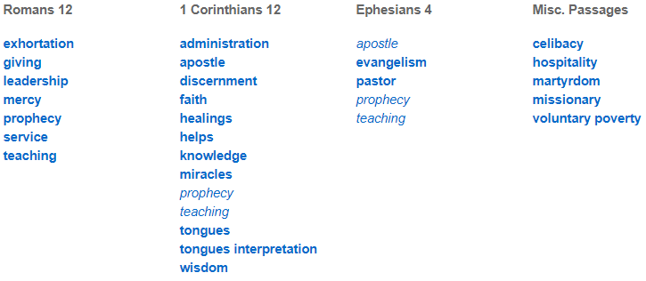

Which spiritual gifts are for today?

A few preliminary qualifiers:
- This isn’t a discussion concerning which side believes in the Holy Spirit.
- This isn’t a discussion concerning whether or not someone believes in the empowering presence of the Spirit.
- This isn’t an argument of whether the Holy Spirit gives spiritual gifts to each Christian.
- This isn’t an argument whether God continues to work miraculously and powerfully in people’s lives.

Position #1: SOME of the gifts are still active and available through the Holy Spirit. “Sign” gifts are not.
Best arguments for this view:

1. In the book of Acts, Luke seems to emphasize the point that signs and wonders were uniquely the province of the apostles (Acts 2:43; 14:3; 15:12).
2. There’s never been any person or any group who has continued the ministry of Jesus and the apostles. All healings movements avoid the hardest cases, celebrate partial healings, and fail often.
3. The “sign” gifts have been redefined and broadened to include ways of talking about these gifts that aren’t biblical.
4. While the gifts are given to build up the church, the “sign gifts” as commonly practiced don’t seem to lead to unity and peace across the body of Christ.

Position #2: ALL the gifts are still active and available through the Holy Spirit.

Best arguments for this view:

1. Jesus intends a continuity his ministry with ours (Luke 9:2, 10:9, John 14:12).
2. We see “regular” Christians performing signs and wonders in the New Testament (e.g. Stephen and Philip in Acts 6:8 and 8:6).
3. 1 Corinthians 12:28-30. Gifts are miracles and healings are distinguished from the gift of apostles.
4. Nowhere does the NT ever suggest that certain spiritual gifts were uniquely and exclusively tied to a particular time or place, or that certain gifts were to cease.
5. Paul commanded the entire church in Corinth (1 Cor. 14:1)

Where I stand:

View ____________

“Conscious dependence on the Holy Spirit”

DANGERS WITHIN EACH VIEW
View #1 (SOME of the gifts are for today): Church cultures of ______________, ________________ ________________________

View #2 (ALL of the gifts are for today): Church cultures of ___________________________ that can be easily exploited by ______________________________________.

A Spirit-Filled Life

I believe a Spirit-filled Christian is one whose life is increasingly conformed to this vision: they passionately love God heart, soul, mind, and strength, and through the Holy Spirit’s power they love their neighbour as themselves.

Questions for Discussion:
1. What was the most memorable or personally impactful part of this message for you?
2. Which of the two views of the spiritual gifts do you currently hold to? How did you arrive at your convictions?
3. Why doe you think the four qualifiers Jeff noted at the start of the message are so important for Christians on both sides of the issue to remember and honour?
4. Read through the Scriptures related to each argument together.
5. Can you think of other arguments for View #1 that were not offered by Jeff but that you find compelling?
6. Can you think of other arguments for View #2 that were not offered by Jeff but that you find compelling?
7. Do you think it was wise or unwise for the Evangelical Covenant Church to summarize their position on this issue as “conscious dependence on the Holy Spirit”? Give reasons for your answer.
8. Would you define “A Spirit-Filled Life” differently than Jeff did above? How would you describe it in your own words?

